Registration Form
A separate registration form must be filled out for each team.
The eligible categories and their codes can be found at the bottom of the this form.
Club name:
Code of Category:

Code of Category
Please indicate the number of the Level or in performance cheer category small or large team. Example.: JAGS L4 or MHHT L

 | Name of athlete | Date of birth  (Day, Month, Year | Passport or Id.card No
01
02
03
04
05
06
07
08
09
10
11
12
13
14
15
16
17
18
19
20
21
22
23
24

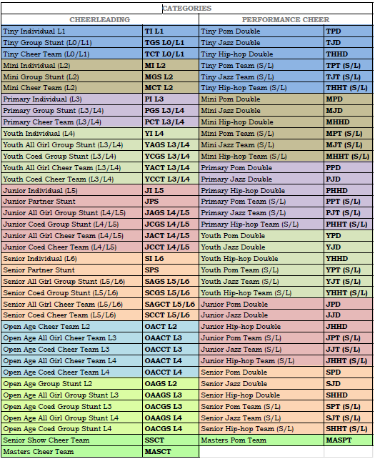
**(S/L): Small / Large Team | SMALL: 4-15, LARGE 16-24 FŐ**

