Competition Notice
II. Winter Cheer Cup
We hereby announce the
NATIONAL CHAMPIONSHIP
and
ECL INTERNATIONAL OPEN CHAMPIONSHIP
for members of the Hungarian Cheer Federation and all interested participants.

VENUE AND DATE OF THE COMPETITION

OSP – Olympic Sports Park
Győr, Radnóti Miklós street. 46, 9025

December 6, 2025

ORGANIZER OF THE COMPETITION
Győr Sharks American Football Sports Association
E-mail: wintercheercup@gmail.com
Responsible person: Viktória Kovács
ENTRY FEE:
Entry ticket: 2,500 HUF / person = 6,5 euro
Tickets are available at the venue. Free entry is granted for competitors, one coach per club (as indicated on the registration form), and one official escort per 10 athletes (pre-registered by the club).
REGISTRATION FEE:
For Hungarian Cheer Federation member clubs: 6,000 HUF /16 euro/ person /16 euro category (includes federation fee)
For non-member clubs: 7,000 HUF /18 euro/ person / category
Registration deadline: November 5, 2025
Applications must be submitted by email by this deadline! (registration form(s), summary, team list)
E-mail: wintercheercup@gmail.com
Music submission deadline: November 15, 2025
Registration fees must be transferred to:
Győr Sharks AFSE
IBAN: HU35117370072371899700000000
SWIFT: OTPVHUHB
Account number: 11737007-23718997
Address: 1051 Budapest, Nádor utca 16.
Payment must be made together with the registration, but no later than November 15, 2025.
RULES:

The valid ECU 2025 Competition Rulebook

Hungarian Cheer Federation – Show Cheer Team Category: Rules and Scoring Criteria

2025 age groups apply, except for Cheerleading Division Open Age categories.

Link: https://www.cheerunion.eu/competitions/rules/rules-documents/

PERFORMANCE ORDER:

The start list will be determined by drawing lots and published in advance by the organizer. Special requests will be considered as much as possible.

AWARDS:
- Partner Stunt / Double categories: medals and certificates for 1st–3rd place
- Group Stunt / Team categories: medals, certificates, and Champion Banner for 1st–3rd place
- From 4th place onwards: certificate of participation
COMPETITION FLOOR:
Cheerleading: 12x12 m spring floor
Performance cheer: 12x12 m dance floor
MUSIC:
Music must be submitted by e-mail no later than November 15, 2025.
Requirements:
- MP3 format

File name: CLUBNAME_ROUTINENAME_CATEGORYCODE.MP3

Please note: music cannot be submitted at the venue. For safety, all teams must also bring their music on a USB stick.

OPEN AGE CATEGORIES:

Open Age Team/Group Stunt Intermediate L2: ages 7–13 (born 2018–2011)

Open Age Team/Group Stunt All Girl/Coed Median L3: ages 9–16 (born 2016–2008)

Open Age Team/Group Stunt All Girl/Coed Advanced L4: ages 13–18 (born 2012–2006)

IMPORTANT INFORMATIONS:
- Participation in registration is mandatory, at least 2 hours before floor performance.
- For Hungarian Cheer Federation member clubs: each athlete must have a valid competition license, federation confirmation (if newly issued), and valid sports medical certificate. Without these, the athlete may not join the team or compete.
- For non-member clubs: athletes must present valid photo ID and a valid sports medical certificate.
- License check (face check) will be carried out before the team’s performance to prevent substitutions. Coaches are responsible for presenting the correct licenses. Foreign athletes must present valid ID at the check.
- Clubs must respect the allowed number of coaches and assistants: 1 coach per club, and 1 assistant per 10 athletes (free of charge if pre-registered).
Extra coaches/assistants may only enter after paying the entry fee.
- If registration fees are not paid on time, the club must pay on-site in cash, with a 30% late fee. Otherwise, the team cannot compete.
- There will be no shared placements (ties). In case of identical total scores, judges will review and adjust scores under the head judge’s supervision.
- We kindly ask all club leaders, representatives, coaches, assistants, and athletes to follow the instructions of the organizing (and possibly security) team to ensure a smooth and timely competition.
- Please pay special attention to punctuality in order to support the organizers’ work.
- (S/L): Small / Large Team | SMALL: 4–15 athletes, LARGE: 16–24 athletes
CATEGORIES CODE: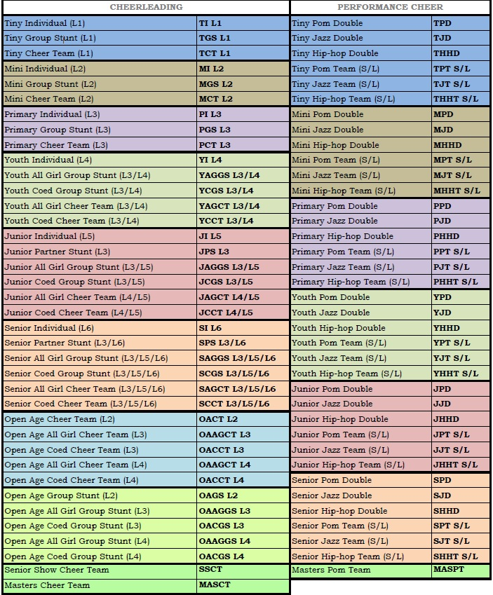

**(S/L): Small / Large Team | SMALL: 4-15, LARGE 16-24 FŐ**

